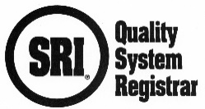
R20.44SRSMS Process Matrix for ISO 28000:2022

Company Name |  | Plant / Facility
Completed By |  | Date

INSTRUCTIONS: Management Representative or Delegate to complete the table below with process names and process owners. Indicate which processes are associated with which clauses by placing an “X” in the corresponding spaces in the table below.

Process names must match those identified in your Management System documentation.

Processes must include those required for product and service realization (Key Processes). Please limit or consolidate other processes that are part of the Management, Resource, and/or Improvement activities, or that support any of those activities. Each process must have measurements and objectives for these measurements. SRI auditors will review your progress toward meeting these objectives during each audit.

Applicable Clauses |  | 4.0 | 5.0 | 6.1 | 6.2 | 6.3 | 7.1 | 7.2 | 7.3 | 7.4 | 7.5 | 8.1 | 8.2 | 8.3 | 8.4 | 8.5 | 8.6 | 9.1 | 9.2 | 9.3 | 10.1 | 10.2
Auditee Process | Owner

