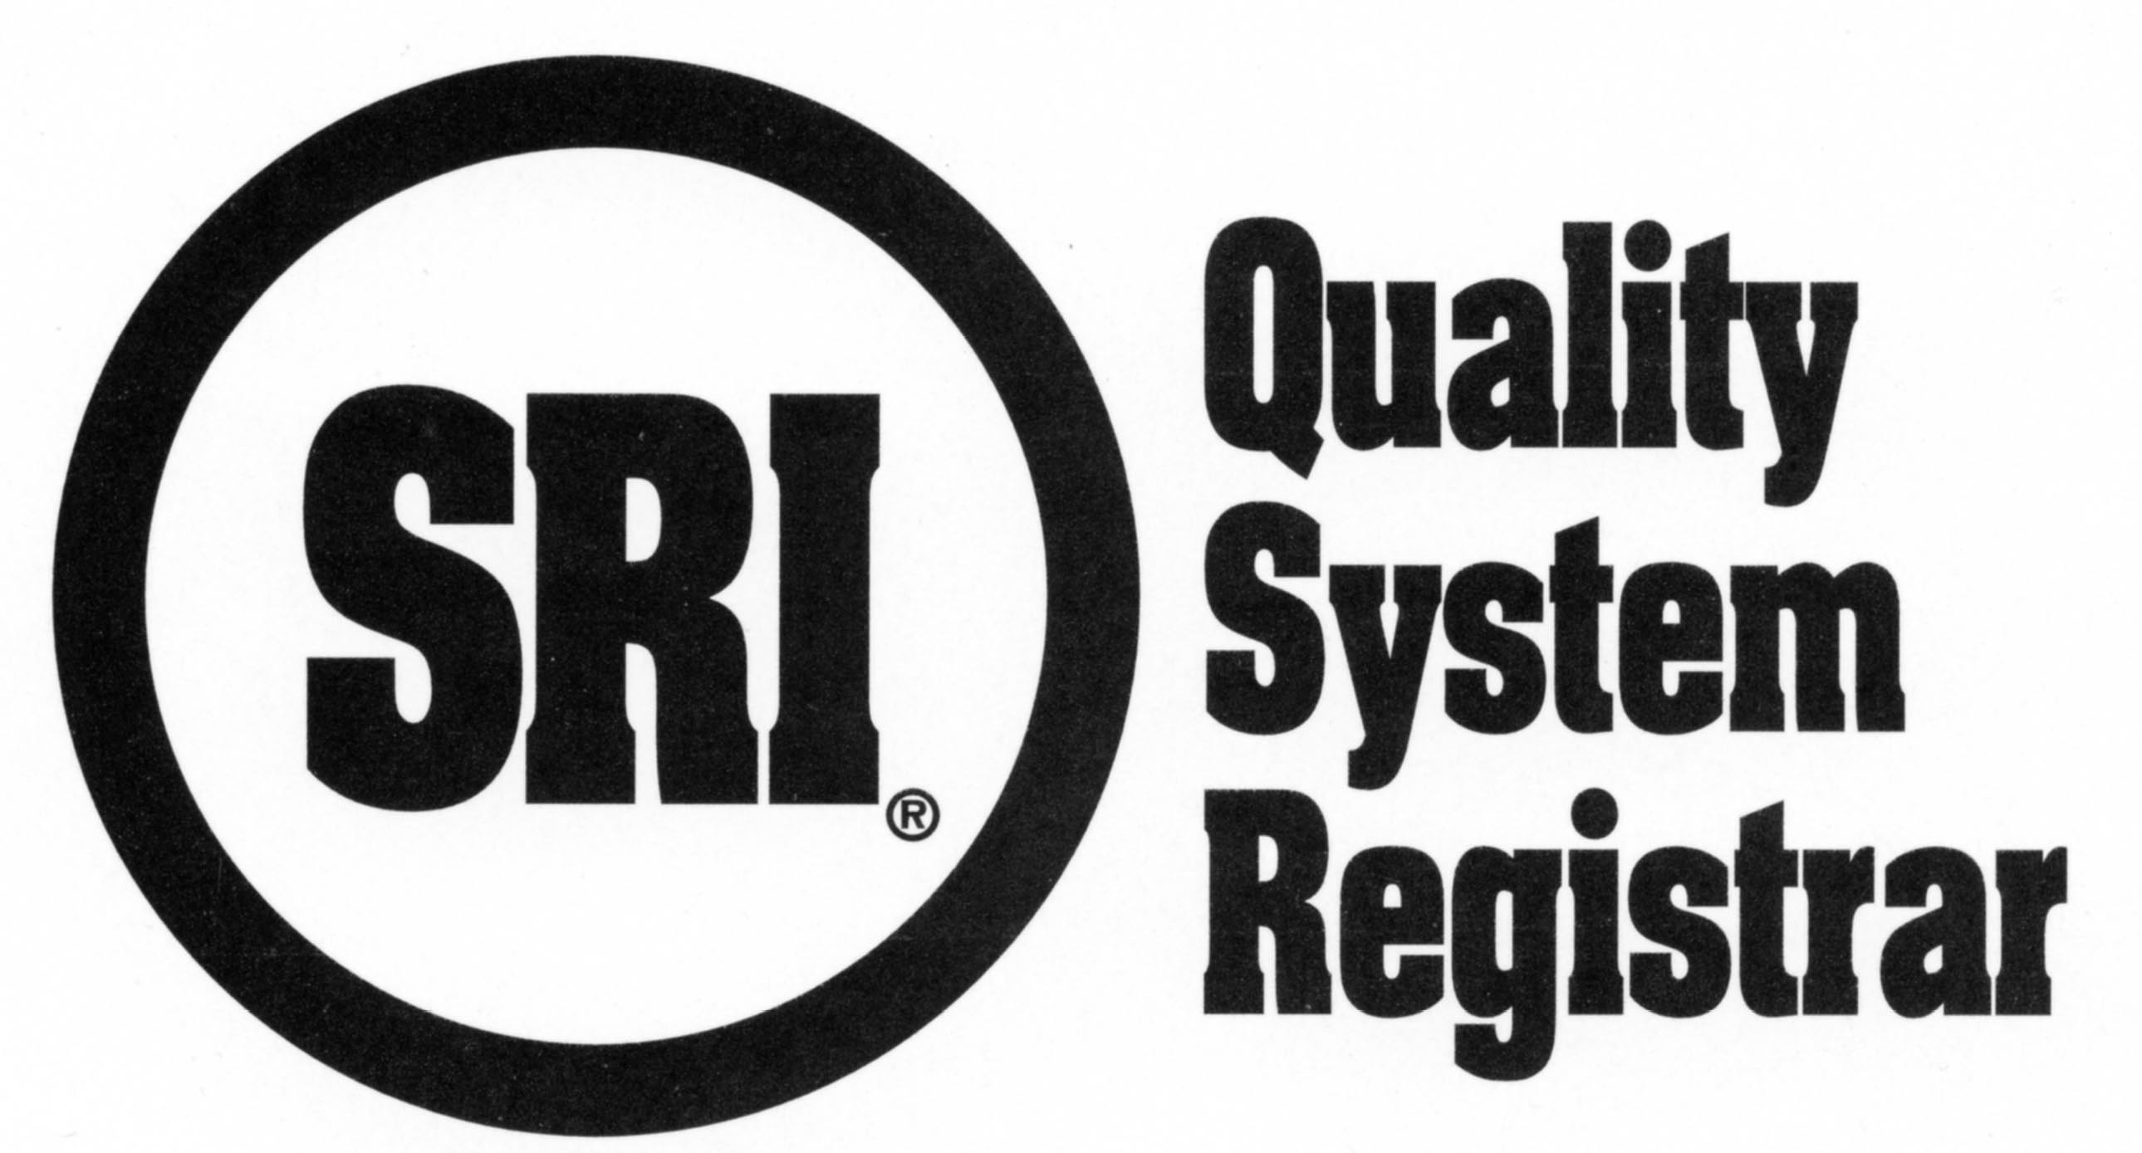
R20.44SCSMS Process Matrix for ISO 28000: 2007

CLIENT INSTRUCTIONS: The management representative or delegate is to indicate the processes needed for their management system (re in the blank area under “auditee process” along with the appropriate process owner and placing an “X” in the matrix indicating the clause(s) that support the noted process. These processes must match those identified in your management system documentation. See notes below.

This is not a responsibility matrix. This completed matrix or an equivalent, is required to plan upcoming audit activities i.e., registration, surveillances. (See example of Delivery, note this may not reflect your actual practices.) Please return to SRI.

P L E A S E P R I N T
Company Name
Plant/facility
Completed by & Date

X = Identifies auditee processes, process owner, and corresponding applicable clauses |  | Applicable Clauses
 |  | 4.1 | 4.2 | 4.3.1 | 4.3.2 | 4.3.3 | 4.3.4 | 4.3.5 | 4.4.1 | 4.4.2 | 4.4.3 | 4.4.4 | 4.4.5 | 4.4.6 | 4.4.7 | 4.5.1 | 4.5.2 | 4.5.3 | 4.5.4 | 4.5.5 | 4.6
Auditee Process | Owner
example only  Delivery | General Foreman | X | X |  | X |  | X |  | X |  |  | X | X |  |  |  |  | X |  |  | X

Important Notes: Processes must include those required for product and service realization (often known as “Key” processes). Please limit or consolidate other processes which either are part of the quality, management, resource, and improvement activities, or support these activities. Remember that each process must have measurements and objectives for these measurements. SRI auditors will review your progress toward meeting these objectives during each audit.

